NOVEMBER 2022

MESSENGER
a monthly publication
of
First Congregational
United Church of Christ
121 First Avenue SE
Watertown,
South Dakota 57201

Mail: P.O. BOX 111
Website: https://www.uccwatertown.com
E-Mail: ucc1wtn@midco.net
Phone: (605)886-6994
Office: 8:00-12:00, M-F
Sunday Worship - 10:00 a.m.
Youth Church School
Sunday 10:20am – 11:00am
Facebook Search: @firstcongregationalwatertown

Minister:
Pastor Dustin Bartlett
Co — Moderators;
Amber Nogelmeier &
Jim Clendenin
Treasurer & Financial Secretary:
Brenda Zemlicka
Youth Director:
Kellen Anderson
Music Director:
Bruce Reinhardt
Secretary:
Virginia McDaniel
Custodian:
Scott Anderson


Pastor's November Message
Siblings in Christ,

We have spent the last several months in what the liturgical calendar refers to as “ordinary time.” While some of the stories from the Bible we’ve heard in worship were anything but ordinary, “ordinary time” refers to the long stretch between Pentecost and All Saints Day in which there are no major holy days or liturgical seasons.

But now, we’re getting back into holy days and liturgical seasons!

This first Sunday in November, we’ll celebrate All Saints Sunday. All Saints Day actually falls on November 1st, but since that’s not a Sunday, we’ll celebrate in worship on November 6th. If you have lost a friend or family member in the last year, you will be invited to light a candle in their memory and speak their name in worship during our service of remembrance.

Christ the King Sunday falls on November 20th, in which we honor Jesus as Lord – the one we have chosen to rule in our hearts and in our lives.

Then, on November 27th, Advent begins. I’ve decided to get off the lectionary during Advent to preach a sermon series focused on mental health. We often think of the holidays as a festive season, but for some people, the holidays are hard. The lack of sunlight and opportunities for outdoors exercise isn’t good for anyone’s mental health. There can be a lot of stress about finances around the holidays. If you recently lost a loved one, this might be the first holiday season without them. And some people come from toxic family situations and have never had the “family holiday” that many of us associate with Thanksgiving and Christmas.

To make it worse, the holidays are a time when so much of society is telling people to be holly and jolly. What do you do if you aren’t? Where do you turn?

So, we’ll be focusing on mental health during the season of Advent, with a self-care Advent calendar and a Longest Night/Blue Christmas service on December 21st. And, as always, I’m available if you need to talk. About anything.

Blessings,

Rev. Dustin Bartlett


November Co-Moderator Report
Greetings,

Thanks to all who attended the retreat at Joy Ranch in October. As a group, we attended church on site, ate lunch together, and engaged in deep conversation. Our core values determined by those in attendance relate to agape love, church family, and faith journey. Based on the discussion, I believe these core values will ring true to each one of you as well who were not able to attend. We discussed the church vitality survey results and met in small groups to identify values, mission and goals of the church. At the Annual Meeting in January, plan to discuss and perhaps adopt a new mission and vision statement. Additionally, we discussed ways to impact our congregation and the community in the "now." One group proposed having a booth at the Zoo Boo, which we will do and pass out goodies to trick or treaters, on behalf of our church. Also, you'll see things such as game/activity nights at the church to bring all of us together. Very exciting stuff!
Jim and I want to send an extra thank you to our church employees, committee members, and volunteers. This place couldn't run without each and every one of you.
Co-Moderator
Amber Nogelmeier
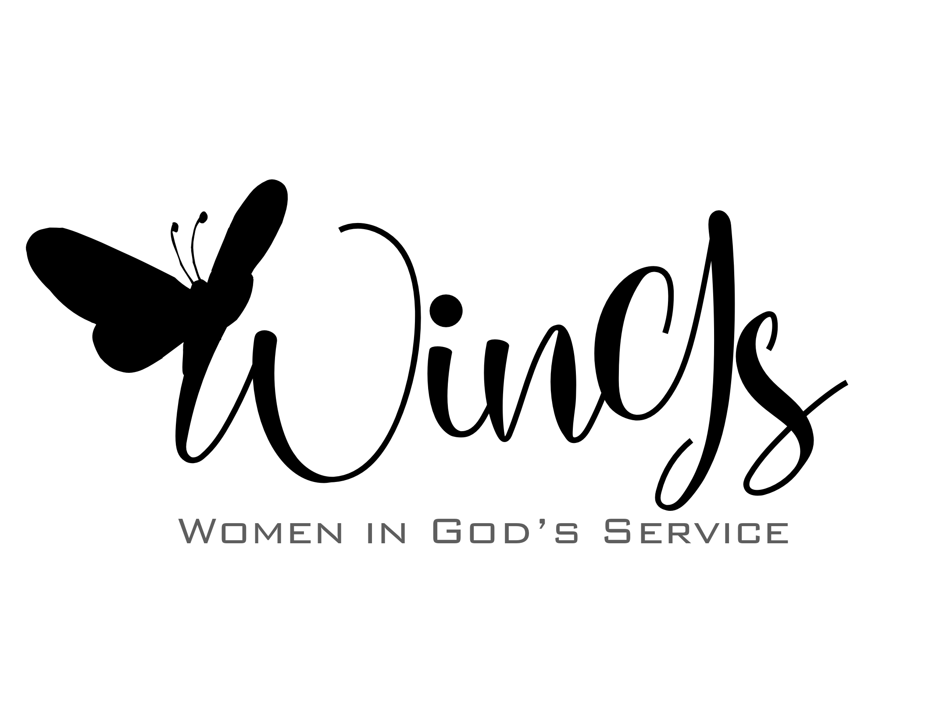

WinG’s (Women’s Fellowship) for November
WINGS will meet Wednesday, November 2 at 1 pm in the church fellowship hall.
Cyndy will be our hostess, a speaker has not been confirmed yet. Everyone is invited to join in this social time.
“Listen and Silent have the same letters”, Coincidence?

May God smile on you ~~ Marlys Moore



Church Council Meeting
Oct 12, 2022
Attendance: Co-moderator Amber Nogelmeier; Co-moderator Jim Clendenin; Alan Pearson; Melissa Pond; Brenda Foster; Robin Briggs; Jordan Zemlicka; Pastor Dustin Bartlett; Treasure Brenda Zemlicka
Unable to attend: Rodney Zemlicka; Kim Bellum; Theresa Igo; Linda Boyken
Call to order: Amber Nogelmeier called the meeting to order. Prayer was provided by Pastor Dustin.
Circle Question: What is your favorite Halloween candy? All present responded to the question and the meeting was started.
Approval of September 14, 2022 council minutes: Motion made by Jim Clendenin to approve the minutes, seconded by Brenda Foster.
Approval of Oct 3, 2022 special council meeting minutes: Motion made by Jim Clendenin to approve the minutes, seconded by Alan Pearson.
Treasurer’s report presented by Brenda Zemlicka: Brenda explained the amount in line item 213 was for payment for the fans and for the Zoom video subscription. Also, the amount in line item 208 is for the post office box rent. Also reported that the paperwork has been filed and sent to withdraw $10,000 monthly from the UCC fund for 6 months and this will start in October. Brenda Foster moved to approve the treasurer’s report, seconded by Jim Clendenin.
Pastor’s report: Pastor Dustin reported on the highlights of the Church retreat held at Joy Ranch. He talked with the council regarding potential vision statement, mission statement and potential ministry ideas. He reported the Tri-Conference annual meeting went well. The new executive conference minister, Phil Hart is leading the conference in a good direction. Pastor mentioned our delegates attending the annual conference, Lynn Forbush and Rich Mittelstedt, did a great job representing our congregation. Pastor encouraged a membership review and council decided to put together a task group to complete this project. Pastor Dustin reminded the council to attend the all staff dinner, 10.13.2022. Scott was able to fix the blowers. Johnson Controls will replace a part on the boiler. Reviewed upcoming holidays, All Saints Day, Thanksgiving and Christmas to get an idea of what our church has done in the past for these holidays.
Christian Education Report: No report this month
Old Business:
- Abuse Prevention Policy-tabled until next month
- Council/Employee Dinner-reminder staff dinner 10.13.2022
- All Church Retreat/Joy Ranch-Pastor Dustin reviewed in his report. Council members asked to think about mission ideas.
- Church School Update-Nothing to report
- Membership list update-Asking for congregation members to form a task group to work on the membership list to get it updated.
- Video/Audio equipment-New hanging microphones have been ordered from Mid States Audio and Video.
New Business:
- Zoo Boo-Our church will have a booth at this year’s Zoo Boo. 3,000 Coloring books and bags of candy have been purchased. This was made possible thanks to the Willa Austin Memorial Fund.
- Hope For Life-Pastor Dustin was contacted to see if our church was open to letting Hope For Life hold their church services in our building until they find a new building.
- Moderator Elect Needed-Annual meeting is in January and Amber Nogelmeier stressed the need for someone to volunteer for moderator elect for next year.
- Jim Clendenin reported he has placed calls for quotes on replacing the non-working kitchen lights.

→→→

Next council meeting: Wednesday, November 9, 2022 at 6:00 pm
Executive Session: Executive session in at 7:00, out of executive session at 7:30
Motion by Jim Clendenin to end executive session, seconded by Brenda Foster.

Motion by Jim Clendenin to adjourn the council meeting, seconded by Melissa Pond.

Notes respectfully submitted,
Melissa Pond


YOUTH GROUP REPORT
In Sunday school, the children completed their mod-podge leaf project and it's now
on display by the stairs. With that, the children learned about the Golden Rule,
and to treat others as they would like to be treated.
They also created their positivity bags for this year and read about the Prodigal Son, learning that no matter what
they do, God will always be there to welcome them back.
~ Kellen

First Congregational United Church of Christ Non-Profit Org.
PO Box 111 U.S. Postage Paid
Watertown, SD 57201 Watertown, SD
THE MESSENGER, NOVEMBER 2022 Permit # 499


Come Worship with us, with
Pastor Dustin Bartlett
10:00 am Sunday
Everyone is always welcome



Meals On Wheels will be Monday, November 28 through Friday December 2,
if you are able to help deliver, please call Lynne Forbush, 605-880-5379, to let her know.
Your help is always appreciated.

