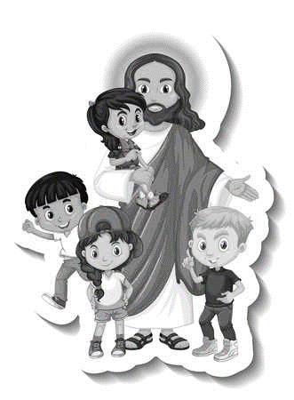
Christian Youth Group, On Summer Break

 | July 2022
Sun | Mon | Tue | Wed | Thu | Fri | Sat
 |  |  |  |  | 1 | 2
3  Communion  Sunday | 4 Evan Otto  HOLIDAY  PARADE 2:00 pm | 5  Oliver Foster | 6  Linda Fjerstad | 7  Judith DeWall | 8 | 9
10  Church council mtg. 11:05 am  Bible Study, 3pm  Fellowship Hall | 11  MEALS ON WHEELS | 12  Rich Mittelstedt  Aubree Trupe  JULY 11 THROUGH | 13  Bible Study, 3pm  Fellowship Hall  JULY 15 | 14 | 15 | 16
17 | 18 | 19  Kim Bellum | 20  Lucas Nogelmeier  Connor Fransen | 21  Miles Nogelmeier | 22  Mary Ann McAtee | 23  Alex Legg
24  Bible Study, 3pm  Fellowship Hall | 25  Bruce Gaede | 26  Jan Tate | 27  Bible Study, 3pm  Fellowship Hall | 28 | 29  Britney Hay | 30  Melissa Nguyen
31 | Bible Study, second & fourth Sunday’s and second & fourth Wednesday’s every month, 3:00pm  Pub-Theology; every Monday evening, 6:00 pm @ Dempsey’s pub  Meals On Wheels, July 11 through July 15, 2022  July 4th parade candy toss at 1:45pm. Parade is 2 pm, route is 4th Street & East Kemp & continues west to the Watertown Stadium.

