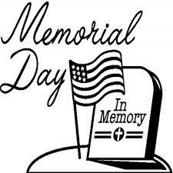
May 2022
Sun | Mon | Tue | Wed | Thu | Fri | Sat
1  Communion Sunday | 2  Jan Goldhorn  Meals On Wheels  May 2 thru May 6 | 3 | 4  WinG’s meeting 1:00 pm | 5  Sue Pearson  Barb Nelson | 6  Emily Brown | 7
8  Mother’s Day | 9  Phyllis Krull | 10 | 11 | 12  Bill Neale | 13 | 14
15  Confirmation –  Graduation  Celebration  Jeann Bevers  Gwen Brophy | 16 | 17  Courtney Fransen | 18  Marlys Moore  Joanne Andersen | 19  Joyce Ruesink | 20 | 21  Shantel Ries
22  Church council meeting 11:05 am | 23 | 24 | 25 | 26 | 27 | 28
29 | 30  Memorial Day  Ryan Stark  Ron Rames | 31  Don Moore | WinGs will meet on Wed., May 4th at 1 pm. We will be discussing future plans. Join us for a cup of coffee!  May 15, Confirmation celebration for James Clendenin and Graduation celebration for Spencer Legg, all are invited for cake and coffee.

