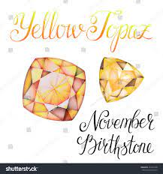 |  | November 2022 |  |  | 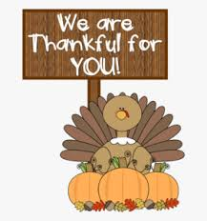
Sunday | Monday | Tuesday | Wednesday | Thursday | Friday | Saturday
 |  | 1 All Saints Day | 2 WinG Meeting  1PM | 3 | 4 | 5
Brenda Zemlicka
Cyndi Spieker
6 Communion  Sunday | 7 Theology on Tap 6pm @ Dempsey’s | 8 | 9 Bible Study 3pm with Pastor Dustin | 10 | 11 | 12
Celebrating All Saints Sunday | Bev Kasdorf  Vina Clendenin | Dylan Rambow | Church council meeting 6PM | Donna Trupe | Bob Holborn  Dawn Engel  Amy Rambow  Bria Miller  Bernie Mason
13 | 14 Theology on Tap  6pm @ Dempsey’s | 15 | 16 | 17 | 18 | 19
Tom Larson | Clark Holborn  Waneta Anderson |  |  |  | Diana Berns | Dustin Zemlicka
20 | 21 Theology on Tap 6pm @ Dempsey’s | 22 | 23Bible Study 3pm with Pastor Dustin | 24 | 25 | 26
 |  |  |  | Thanksgiving Day |  | 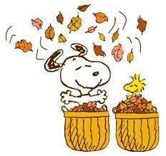
27 | 28 Theology on Tap 6pm @ Dempsey’s | 29 | 30
Ruth Erichsen | Kari Carter  MEALS ON | WHEELS NOV 28 | Alice Phillips  Greg Fransen  THROUGH DEC.2

